Nepal College of Information Technology
Unit Test 2010
Program: BE(IT) Time: 2hrs
Semester: v FM: 70
Subject: Principles of Communication PM: 35

1. | a) | Compare digital communication with analog communication system and explain digital communication system with the help of functional block diagram. | 8
 | b) | State and explain Shannon capacity theorem. Calculate the maximum data rate that could be send over the telephone lines, whose SNR is 10⁴ and passes over the frequency range from 400 to 4000 Hz. | 7
2. | a) | What is Entropy and Information rate? An analog signal of bandwidth 4 kHz is converted to its digital equivalent and transmitted with six symbols Mi for i = 1,2,3,4, 5 and 6. The occurrence probabilities of the six symbols are given by M1 ═> p1 =1/16, M2 ═> p2 =1/4, M3 ═> p3 =3/8, M4═> p4 =1/8, M5 ═> p5 =1/8 and M6═> p6 =1/16. i) What is the average information per symbol? ii) What is the information rate? | 7
 | b) | Consider the binary sequence 0110100101. Draw waveforms for the following signaling format: i) Unipolar RZ ii) Polar NRZ ii) Bipolar RZ and iv) Manchester NRZ | 8
3. | a) | What are deterministic and random waveforms? Find the Fourier Transform and draw the magnitude spectrum of the rectangle function as shown in the figure.  x(t)  1  T | 7
 | b) | Write down the properties of Fourier Transform. | 8
4. | a) | Find the complex Fourier series of the waveform as shown in the figure.  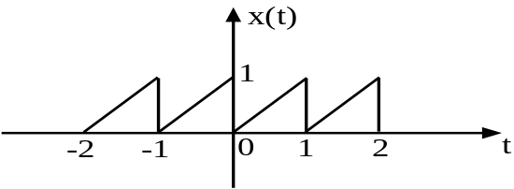 | 7
 | b) | Explain power spectral density and auto-correlation function of a signal. | 8
5. | Write short notes on(Any Two): |  | 2*5
5. | a) | Energy and Power signal | 2*5
 | b) | Propagation of Electromagnetic waves
 | c) | Draw the timing diagram of HDB3 for the following binary sequence. 1101100001011000011

